1. Alan Wadsworth, Tomoyuki Akiyama. Making Every Engineer a Test Expert // European semiconductor April 2005 Vol 27 No 4 www.eurosemi.eu.com/

The history of the modern semiconductor parameter analyzer began with the introduction of the HP
4145A in 1982. Before then, analogue curve tracers were the only available tools for semiconductor device analysis. The semiconductor parameter analyser introduced several revolutionary features. These included source/monitor units (SMUs), which can force and measure current and voltage, and the ability to capture and display data in a digital format. Since then, new versions of the semiconductor parameter analyser have been introduced and each generation has added new features, such as femtoamp current measurement resolution, reliability functions and quasi-static capacitance versus voltage (QSCV) measurement. However, each new generation of parameter analyser has still followed the original concept of the 4145A, which required the user to have detailed knowledge of the functionality of the SMUs in order to create a simple test algorithm.
many algorithms require a complicated test sequence in order to extract the desired data, requiring engineers and researchers to develop programming skills. The second needed improvement is a better means to integrate current-voltage (IV) and capacitance-voltage (CV) measurements. Unlike IV, CV measurements are significantly affected by factors such as cable length, return path and
device under test (DUT) impedance. IV and CV measurement resources do not useIV and CV measurement resources do not use the same types of connectors, so some sort of switching matrix hardware is necessary to connect to standard triaxial probes. Switching matrices however add complexity to the CV measurement environment. In addition, new device structures such as
silicon-on-insulator (SOI) transistors require support for pulsed IV measurements in the nanosecond range due to their increased susceptibility to harmful thermal effects during characterisation.
Accurate and effortless switching between IV and CV measurements is achieved via an SMU CMU unify unit (SCUU), eliminating the need for an external switching matrix.
A library containing more than a hundred algorithms covering a wide variety of processes and device types is also included.
For example, memory cells frequently need sub-1 femtoamp measurement resolution in order to precisely characterise parasitic leakage currents. To obtain this level of resolution, it is necessary to place some portion of the
The B1500A architecture makes it easy to add new solutions in the future to meet changing requirements. As the semiconductor industry crosses the 65nm and 45nm milestones andrequires extremely fast pulsed IV measurements, it is simple to add solutions that coordinate the B1500A measurement resources with external pulse generators such as the Agilent 81110A. In addition, it is also straightforward to add high frequency CV solutions (>5MHz) using the Agilent 4294A and RF CV solutions (to 8.5GHz) with the Agilent E5071B.
In short, the B1500A provides the characterisation capabilities to meet the needs of the semiconductor industry well into the next decade.

2. Application Note B1500-1 Measuring CNT FETs and CNT SETs Using the Agilent B1500A

3. Application Note B1500-2 Migrating from the Agilent 4155C and 4156C to the Agilent B1500A

This application note presents the B1500A’s major features and examines both the differences and similarities of the two product lines.
The Agilent B1500A Semiconductor Device Analyzer represents a new paradigm in semiconductor parameter measurement. It is designed to meet the challenges of current 65-nanometer and future sub 45-nanometer process technologies. The Agilent 4145, 4155 and 4156 series of instruments has been the de factoindustry standard for semiconductor parameter analyzers formore than 20 years. These instruments all employed a similar measurement concept, in that the user was required to have an intimate understanding of the SMU hardware in order to make even a simple measurement. The B1500A with EasyEXPERT software employs a completely different task-oriented measurement approach using application tests. It does not require the user to learn the instrument hardware in order to make productive measurements, which makes the B1500A a better choice for new or occasional users. In addition, EasyEXPERT provides a Classic Test mode (shown in Figure 10) that duplicates the familiar 4155 and 4156 interface, and measurement setups created in the 4155 and 4156 can be imported into the B1500A classic test mode. Of course, users already familiar with the 4155 and 4156 user interface can use the B1500A entirely from the classic test mode if they choose. Desktop EasyEXPERT software provides additional versatility for efficient use of the B1500A and allows the analysis of measurement data analysis on an external Windows-based PC. At this time a majority of the 4155 and 4156 measurement solutions can be performed more efficiently on the B1500A. A few measurements such as quasistatic capacitance versus voltage (QSCV) measurement are not yet supported on the B1500A, but there are plans to support this in future software releases.
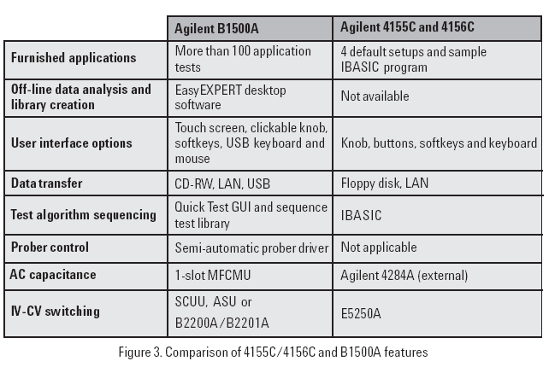
Key to acronyms: IV = Current versus voltage CV = Capacitance versus voltage SMU = Source/monitor unit HPSMU = High power source/monitor unit MPSMU = Medium power source/monitor unit HRSMU = High resolution source/monitor unit CMU = Capacitance measurement unit MFCMU = Multi-frequency capacitance measurement unit SCUU = SMU CMU unify unit ASU = Atto-sense and switch unit DUT = Device under test

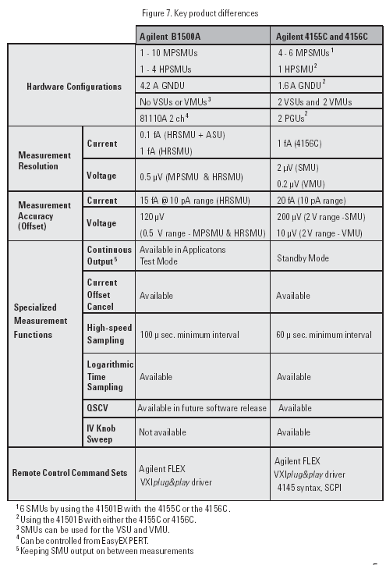
4. Application Note B1500-5. Creating a Test Sequence Using Agilent B1500A EasyEXPERT Software

5. Self-paced Training Manual

New Features
• EasyEXPERT software
• Application test environment (> 150 algorithms)
• Classic test environment – 415x like setup
• Quick test environment – multiple test execution
• Semi-auto prober control and B2200 switch control
• Modular mainframe
• MFCMU for C-V sweep
• HPSMU, HRSMU, MPSMU for I/V sweep/sampling
• SMU CMU Unify Unit (SCUU)/Guard Switch Unit (GSWU)
• switching effortlessly between IV and CV measurement
• Atto Sense/Switch Unit (ASU)
• 100 aA level low current measurement
• Touch-screen, knob, and softkeys
• optional USB keyboard, mouse, and stylus pen
The EasyEXPERT software
•Task-oriented, “top-down” approach to device characterization
•Multiple test execution
•Automatic measurement, auto-analysis functions
•Test sequencing without programming
Application Library (>150 algorithms)
•Categorized and organized
•Easy-to-use
415x setup file converter program
Versatile Modular Mainframe
•Flexible & Expandable (10 slots)
•Multiple SMU types
•Atto-sense and Switch Unit (ASU)
•Multi-Frequency CMU
•SMU CMU Unify Unit for IV/CV Probing
•4.2 Amp Ground Unit
Convenient User Interface
•Touch screen operation (with optional stylus pen)
•Contextual softkeys & knob control
•Optional USB keyboard & mouse
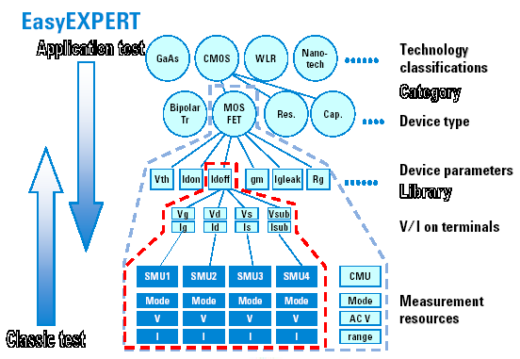

User Interface
• Touch panel
• Stylus pen (option)
• Rotary knob
• Softkeys
• USB keyboard (option)
• USB mouse (option)
Modular Mainframe
The following modules and accessories are available for the B1500A:
•B1520A CMU: 1 kHz to 5 MHz CV capability (1 slot)
•B1511A MPSMU: 100 mA/100 V force capability, 10 fA/0.5 mV measurement resolution (1 slot)
•B1517A HRSMU: 100 mA/100 V force capability, 1 fA/0.5 mV measurement resolution (1 slot)
•B1510A HPSMU: 1 A/200 V force capability, 10 fA/2 mV measurement resolution (2 slots)
•N1301A-100/102: SMU CMU unify unit (SCUU) & cable assembly
•N1301A-200/201/202: Guard switch unit (GSWU) & cable assembly
•E5288A ASU: 0.1 fA/0.5 mV measurement resolution with support for IV/CV switching
The ASU (Atto sense/switch unit) can be used with the HRSMU calibrated with it.
The SCUU can be used with the CMU (slot N), SMU (slot N-1), and SMU (slot N-2).
The GSWU can be used with the SCUU.
B2200 Switch Control
• Allows use of a probe card to facilitate probing of standardized device
modules (usually 24-pin configuration)
• Enables easy multiplexing between the triaxial outputs of SMUs and
the coaxial outputs of other (BNC-based) instruments and modules
Desktop EasyEXPERT Software
The Desktop EasyEXPERT software provides the following additional advantages to the B1500A,
allowing you to minimize the amount of offline tasks performed on B1500A and increase the
working ratio for measurements.
•Allows B1500A to be controlled from an external computer via GPIB while online.
•Allows test setup to be created on an external computer while offline.
•Allows data analysis to be performed on an external computer while offline.
To Use Built-in Functions
Absolute value: abs(A)
Averaging: avg(A), mavg(A,B)
Data conversion: string(A), value(A)
Difference: delta(A)
Differentiation, integration: diff(A,B), integ(A,B)
Exponent, logarithm: exp(A), lgt(A), log(A)
Maximum, minimum: max(A), min(A)
Reading data : getNumericData(A), getVectorData(A)
Square root: sqrt(A)
Trigonometric function: acos(A), asin(A) , atan(A), atan2(A,B),
cos(A), sin(A), tan(A)
Classic Test Execution Mode
To use the classic test mode, click the Classic Test tab. And select the execution mode. The
following modes are available.
•I/V Sweep: For X-Y characteristics measurement of I or V.
•I/V-t Sampling: For time-Y characteristics measurement of I or V.
•C-V Sweep: For DC bias-impedance characteristics measurement.
•Switching Matrix Control: For B2200 switching matrix control.
To Control External GPIB Devices
Miscellaneous: GPIB I/O
Write String to send a string command to GPIB device
Write Value to send a command to GPIB device
Read String to read a string value from GPIB device
Read Value to read a numeric value data from GPIB device
Read List to read a vector data from GPIB device
Read STB to read status byte of GPIB device
GP-IB Control Group Execution Trigger
Device Clear
Go To Local
Local LockOut
Miscellaneous Operations
• Function Status Indicator
• Automatic Data Export and Data Record
• Calibration
• Configuration
• XSLT Samples
The XSLT sample files are stored in the following folder. The files can be used as a XML style sheet file for exporting test data record.
C:\Program Files\Agilent\B1500A\EasyEXPERT\Utilities\XSLT
csv.xsl:
This file can be used to export test record in the format that uses a comma (,) as data separator. This file is used to realize the Export As CSV... function.
tab-sv.xsl:
This file can be specified in the XML Style Sheet File Path field in the Export Using XSLT dialog box if you want to export a test record in the format that uses a tab as data separator.
xmlss.xsl:
This file can be used to export test record in the XML Spread Sheet format. This file is used to realize the Export As XML Spread Sheet... function.
• To Enable System Controller
• To Start Desktop EasyEXPERT
• To Use Setup File Converter

6. Agilent B1500A Semiconductor Device Analyzer Technical Overview June 2006 Ten Nanosecond Pulsed IV Parametric Test Solution

Already possessing superb dc measurement performance, the B1500A with EasyEXPERT software
Now supports a pulsed IV measurement solution utilizing an Agilent 81110A pulse pattern (образец) generator and Agilent DSO80000B /54850 series scope that can characterize MOSFETs with an unprecedented gate pulse width of 10 nanoseconds.
A dc to pulsed IV switching option is available to enable you to toggle between dc measurements and pulsed IV measurements without having to change any cables. This makes it easy to correlate dc measurements with pulsed measurements, and it also permits the automation of this process.
The benefits of this for each technology type are:
For SOI transistors, the short duty cycle reduces self- heating effects that adversely impact the measurement results.
For high- k gate dielectric transistors, the short duty cycle reduces the incidence of electron trapping that distorts measurement results.
7. Making Every User a Parametric Test Expert Making Every User a Parametric Test Expert Agilent B1500A Semiconductor Device Analyzer with EasyEXPERT Software
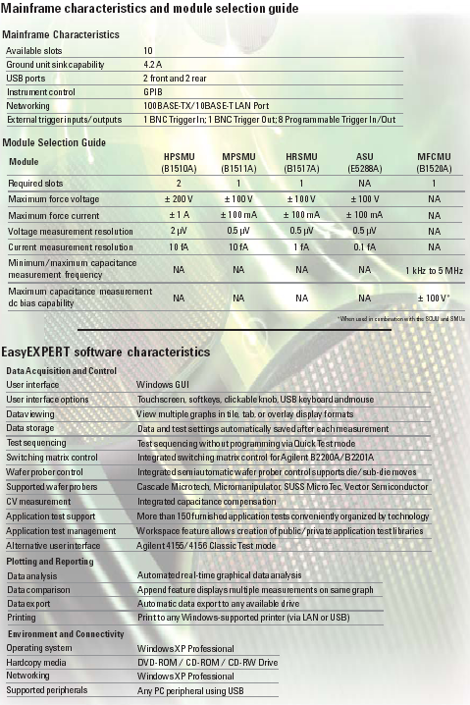
8. Agilent B1500A Semiconductor Device Analyzer Technical Overview April 2006 – Основной документ для изучения.
This new approach is enhanced via a touch screen interface, which makes the instrument as easy to use when racked as when on a benchtop.
The modular 10- slot (посадочное место) configuration
Single- slot capacitance measurement unit (CMU).
An innovative SMU CMU unify unit (SCUU) is available to eliminate cabling confusion when connecting the SMUs and CMU to your positioner- based wafer probing environment.
Basic Features
- EasyEXPERT software resident on instrument
- Performs IV and CV measurements
- Ten module slots
- Multiple SMU types available: MPSMU, HPSMU, and HRSMU
- Multi- frequency capacitance measurement unit (1 kHz to 5 MHz) available
- High- resolution, analog- to- digital converter (ADC) available to all installed modules
- High- speed ADC present on each installed SMU
- 4.2-Amp ground unit
- SMU/AUX path switching available on the Atto Sense and Switch Unit (ASU)
- Supported CMU accessories include SMU CMU unify unit (SCUU) and guard switch unit (GSWU)
- Automatic identification of capacitance measurement accessories (MFCMU)
- GPIB port for instrument control
- Self- test, self- calibration, diagnostics
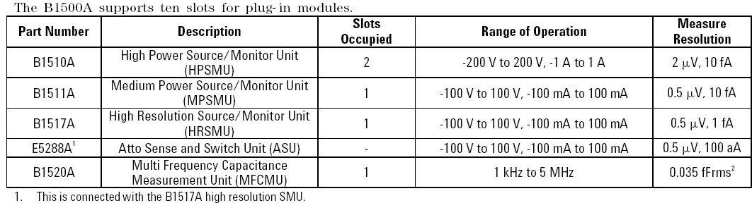
Maximum Output Power
The total power consumption of all modules cannot exceed 82 W.
Pulse Measurement
Pulse width: 500 3sec to 2 s Pulse period: 5 ms to 5 s Period Ў Width + 2 ms (when Width ~ 100 ms) Period Ў Width + 10 ms (when Width > 100 ms) Pulse resolution: 100 3s
Ground Unit (GNDU) Specification
The GNDU is furnished (доставляемый) with the B1500A mainframe. Output Voltage: 0 V ± 100 3V Maximum sink current: ± 4.2 A
Output terminal/connection:
Triaxial connector, Kelvin (remote sensing) (измерение дистанционное)
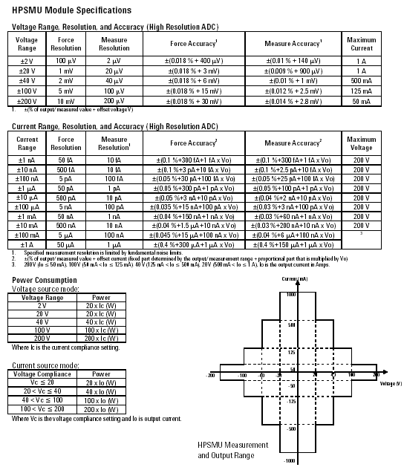

Voltage/Current Compliance (Limiting)
The SMU can limit output voltage or current to prevent damaging the device under test. Voltage: 0 V to ±100 V (MPSMU, HRSMU) 0 V to ±200 V (HPSMU) Current: ±10 fA to ±100 mA (HRSMU with ASU) ±100 fA to ±100 mA (HRSMU) ±1 pA to ±100 mA (MPSMU) ±1 pA to ±1 A (HPSMU)
Compliance (соответствие ) Accuracy: Same as the current or voltage set accuracy.
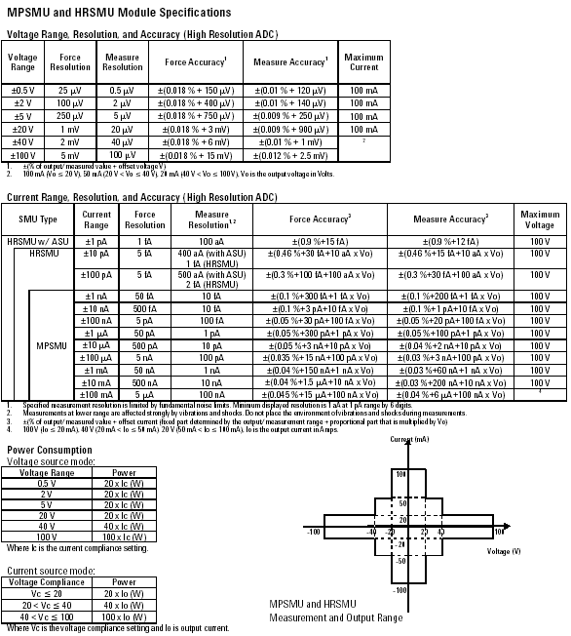
Agilent EasyEXPERT Software Functions
Operation mode:
Application test mode, Classic test mode, Quick test mode
Key Functions:
- Categorized and predefined application library
- Device definition
- Measurement parameter settings
- Save/Recall My Favorite Setups
- Define/customize application library
- Execute (выполнять) measurement (Single/Repeat/Append)
- Quick test execution
- Save/Recall measurement data and settings
- Test result data management
- Import/Export device definition, measurement settings, my favorite setup, measurement data, and application library
- Graph plot display/analysis/printing
- Switching matrix control
- Workspace management
- Self- test, self calibration, diagnostics
Application Library
Category: Sample test definitions for the following applications. They subject to change without notice. Structure, CMOS, Bipolar (BJT), Memory, Mixed Signal Device, TFT, Discrete, Reliability, Power Device, Nanotechnology, Utility
Measurement Mode Details
The Agilent B1500A supports the following measurement modes: Staircase (ступенчатой) Sweep, Multi-Channel Sweep*, Pulsed Sweep, Staircase Sweep with Pulsed Bias, IV Sampling (выборка), High Speed IV Sampling, CV Sweep, Linear Search** (поиск), Binary Search**
* EasyEXPERT supports VAR1 and VAR1’.
**They are supported by FLEX command only.
Each SMU can sweep using VAR1 (primary sweep), VAR2 (secondary sweep), or VAR1’ (synchronous sweep).
Current Offset Cancel
This function subtracts the offset current from the current measurement raw data, and returns the result as the measurement data. This function is used to compensate the error factor (offset current) caused by the measurement path such as the measurement cables, manipulators, or probe card.
Time Stamp (отметка времени)
The B1500A supports a time stamp function utilizing an internal quartz clock. Resolution: 100 us
Other Measurement Characteristics
Measurement Control: Single, Repeat, Append, and Stop.
SMU Setting Capabilities: Limited auto ranging, voltage/current compliance, power compliance, automatic sweep abort functions, self- test, and self- calibration
Arithmetic and Analysis Functions
User Functions
Up to 20 user- defined functions can be defined using arithmetic expressions. Measured data and pre- defined variables can be used in the computation. The results can be displayed on the LCD.
Arithmetic Operators
+, - , *, /, ^, abs (absolute value), at (arc tangent), avg (averaging), cond (conditional evaluation оценка соответствия), delta, diff (differential), exp (exponent), integ (integration), lgt (logarithm, base 10), log (logarithm, base e), mavg (moving average), max, min, sqrt, trigonometric function, inverse trigonometric function, and so on
Physical Constants
Keyboard constants are stored in memory as follows:
q: Electron Charge,
1.602177 E- 19 C
k: Boltzman’s Constant,
1.380658 E- 23
e (e): Dielectric Constant of Vacuum,
8.854188 E- 12
Engineering Units
The following unit symbols are also available on the keyboard:
a (10⁻¹⁸), f (10⁻¹⁵), p (10⁻¹²), n (10⁻⁹), u or μ (10⁻⁶), m (10⁻³), k (10³), M (10⁶), G (10⁹), T (10¹²) , P (10¹⁵)
Analysis Capabilities
Overlay Graph Comparison
A graphics plot can be stored and overlaid (наложен).
Scale
Auto scale and zoom
Marker
Marker to min/max, interpolation, direct marker, and marker skip
Cursor
Direct cursor
Line
Two lines, normal mode, grad mode, tangent (касательная) mode, and regression mode
Automatic Analysis Function
On a graphics plot, the markers and lines can be automatically located using the auto analysis setup.
Parameters can be automatically determined using automatic analysis, user function, and read out functions.
Data Variable Display
Up to 20 user- defined parameters can be displayed on the graphics screen.
Analysis Functions
Up to 20 user- defined analysis functions can be defined using arithmetic expressions. Measured data, pre- defined variables, and read out functions can be used in the computation. The results can be displayed on the LCD.
Read Out Functions
The read out functions are built- in functions for reading various values related to the marker, cursor, or line.
Graph Plot
Display Mode
Data display window can be printed. Only X- Y graph can be printed.
Graph Plot File
Graph plot can be stored as image data to clip board or mass storage device.
File type: bmp, gif, png, emf
Output
Display Modes
X- Y graph, list display, and parameter display
X-Y Graph Display
X- axis and up to eight Y- axis. Linear and log scale. Real time graph plotting
List Display
Measurement data and calculated user function data are listed in conjunction with VAR1 step number or time domain sampling step number. Up to 20 data sets can be displayed.
Other Functions
Import/Export files.
File type:
Agilent EasyEXPERT format,
XML- SS format, CSV format
Data Storage
Hard disk drive
DVD-ROM/CD-R/CD-RW drive
Interfaces
GPIB port for instrument control
Interlock port
USB port (USB 2.0, front 2, rear 2)
LAN interface
100BASE- TX/10BASE- T
Trigger in/out
Generic purpose digital I/O
Trigger I/O
Only for GPIB remote mode.
Trigger in/out synchronization pulses before and after setting and measuring dc voltage and current.
Arbitrary trigger events can be masked or activated independently.
MFCMU (Multi Frequency Capacitance Measurement Unit) Module Specifications
Measurement Functions
Measurement parameters: Cp-G, Cp-D, Cp-Q, Cp-Rs, Cs-Rs, Cs-D, Cs-Q, Lp-G, Lp-D, Lp-Q, Lp-Rs, Ls- Rs, Ls- D, Ls- Q, R- X, G- B, Z- θ, Y- θ
Ranging: Auto and fixed Measurement terminal: Four- terminal pair configuration, four BNC (female) (надеваемый- мама) connectors Cable length: 1.5 m or 3 m, automatic identification of accessories.
Test Signal
Frequency: Range: 1 kHz to 5 MHz Minimum resolution: 1 mHz Accuracy: ±0.008 %
Signal output level: Range: 10 mVrms to 250 mVrms Resolution: 1 mVrms Accuracy: (10.0 % + 1 mVrms) at four- terminal pair port of MFCMU
±(15.0 % + 1 mVrms) at measurement port of MFCMU cable (1.5 m or 3.0 m)
Output impedance: 50 Om typical
Signal level monitor: Voltage range: Same as the voltage signal level setting range
Voltage monitor accuracy (open load): ±(10.0 % of reading + 1 mVrms) at four- terminal pair port of MFCMU
±(15.0 % of reading + 1 mVrms) at measurement port of MFCMU cable (1.5 m or 3 m)
DC Bias Function
DC voltage bias: Range: 0 to ±25 V Resolution: 1 mV Accuracy: ±(0.5 % + 5.0 mV) at the High and Low terminals of the MFCMU measurement port or the MFCMU 1.5 m/3 m cable end
Output impedance: 50 Om, typical
DC bias monitor: Range: Same as the dc voltage bias setting range
Accuracy (open load): ±(0.2 % of reading + 10.0 mV) at the High and Low terminals of the MFCMU measurement port or the MFCMU 1.5 m/3 m cable end
Sweep (развертка) Characteristics
Available sweep parameters: Oscillator (генератор колебаний) level, DC bias voltage, frequency (list sweep only)
Sweep type: Linear, Log Sweep mode: Single, Double Sweep direction: Up, Down Number of measurement points: Maximum 1001 points
Measurement Accuracy
The following parameters are used to express the impedance measurement accuracy at four- terminal pair port of MFCMU and measurement port of MFCMU cable.
Note: measurement accuracy is specified under the following conditions: Temperature: 23°C ± 5°C
Integration time: 1 PLC or 16 PLC
SMU CMU Unify Unit (SCUU) and Guard Switch Unit (GSWU) Specifications
The SCUU switches either (или) two SMUs or CMU to the output port. The MPSMU and HRSMU are supported as a module. The SCUU has dc bias adapter function by the SMU as dc bias source. Also error compensation function is supported. To connect the SCUU, the dedicated cable assembly is supplied. It can help to connect correctly and easily, and it eliminates cabling mistake. The GSWU switches open when using SMUs and close when using CMU for the guard return path automatically depending on which the SCUU output is used for the capacitance measurement or not.
Supported (поддерживаемый) SMU MPSMU and HRSMU
For SCUU
Inputs:
Four triaxial ports: for Force1, Sense1, Force2, and Sense2
Four BNC ports: for MFCMU, One SCUU control port
Outputs:
Four triaxial ports: for Force1/CMUH, Sense1, Force2/CMUL, and Sense2
One GSWU control port Three LEDs (светодиод), SMU/CMU output status indicator
Docking (стыковочный) Mode Direct and indirect mode
For GSWU Input:
One control port from SCUU Mini pin plug мини (штырьковый штепсельный разъем) port: 2 ports (to Guard1, to Guard2
Output:
One LED, connection status indicator
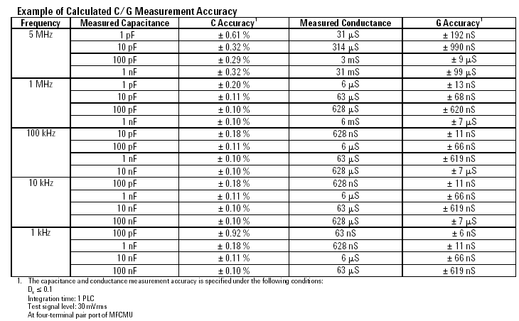
9. C-V измерения
MFCMU (Multi Frequency Capacitance Measurement Unit) Module Specifications
Measurement Functions
Measurement parameters: Cp-G, Cp-D, Cp-Q, Cp-Rs, Cs-Rs, Cs-D, Cs-Q, Lp-G, Lp-D, Lp-Q, Lp-Rs, Ls- Rs, Ls- D, Ls- Q, R- X, G- B, Z- θ, Y- θ
Ranging: Auto and fixed Measurement terminal: Four- terminal pair configuration, four BNC (female) (надеваемый- мама) connectors Cable length: 1.5 m or 3 m, automatic
identification of accessories.
Test Signal
Frequency: Range: 1 kHz to 5 MHz Minimum resolution: 1 mHz Accuracy: ±0.008 %
Signal output level: Range: 10 mVrms to 250 mVrms Resolution: 1 mVrms Accuracy: (10.0 % + 1 mVrms) at four- terminal pair port of MFCMU
±(15.0 % + 1 mVrms) at measurement port of MFCMU cable (1.5 m or 3.0 m)
Output impedance: 50 Om typical
Signal level monitor: Voltage range: Same as the voltage signal level setting range
Voltage monitor accuracy (open load): ±(10.0 % of reading + 1 mVrms) at four- terminal pair port of MFCMU
±(15.0 % of reading + 1 mVrms) at measurement port of MFCMU cable (1.5 m or 3 m)
DC Bias Function
DC voltage bias: Range: 0 to ±25 V Resolution: 1 mV Accuracy: ±(0.5 % + 5.0 mV) at the High and Low terminals of the MFCMU measurement
port or the MFCMU 1.5 m/3 m cable end
Output impedance: 50 Om, typical
DC bias monitor: Range: Same as the dc voltage bias setting range
Accuracy (open load): ±(0.2 % of reading + 10.0 mV) at the High and Low terminals of the MFCMU measurement port or the MFCMU 1.5 m/3 m cable end
Sweep (развертка) Characteristics
Available sweep parameters: Oscillator (генератор колебаний) level, DC bias voltage, frequency (list sweep only)
Sweep type: Linear, Log Sweep mode: Single, Double Sweep direction: Up, Down Number of measurement points: Maximum 1001 points
Measurement Accuracy
The following parameters are used to express the impedance measurement accuracy at four- terminal pair port of MFCMU and measurement port of MFCMU cable.
Note: measurement accuracy is specified under the following conditions: Temperature: 23°C ± 5°C
Integration time: 1 PLC or 16 PLC
SMU CMU Unify Unit (SCUU) and Guard Switch Unit (GSWU) Specifications
The SCUU switches either (или) two SMUs or CMU to the output port. The MPSMU and HRSMU are supported as a module. The SCUU has dc bias adapter function by the SMU as dc bias source. Also error compensation function is supported. To connect the SCUU, the dedicated cable assembly is supplied. It can help to connect correctly and easily, and it eliminates cabling mistake. The GSWU switches open when using SMUs and close when using CMU for the guard return path automatically depending on which the SCUU output is used for the capacitance measurement or not.
Supported (поддерживаемый) SMU MPSMU and HRSMU
For SCUU
Inputs:
Four triaxial ports: for Force1, Sense1, Force2, and Sense2
Four BNC ports: for MFCMU, One SCUU control port
Outputs:
Four triaxial ports: for Force1/CMUH, Sense1, Force2/CMUL, and Sense2
One GSWU control port Three LEDs (светодиод), SMU/CMU output status indicator
Docking (стыковочный) Mode Direct and indirect mode
For GSWU Input:
One control port from SCUU Mini pin plug мини (штырьковый штепсельный разъем) port: 2 ports (to Guard1, to Guard2
Output:
One LED, connection status indicator

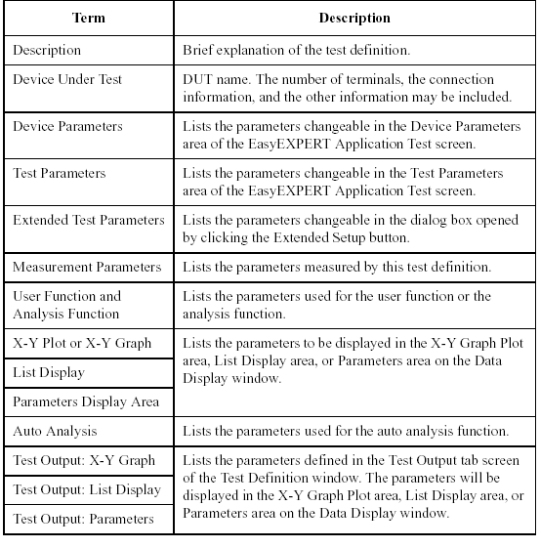
1 BJT
1.7 CS Diode Fwd: Collector-Substrate junction forward characteristics
[Description]
Measures the Collector-Substrate junction forward characteristics of BJT. Base and Emitter are opened.
[Device Under Test]
Bipolar transistor, 4 terminals
[Device Parameters]
Polarity: NPN (SMUs force the specified value) or PNP (SMUs force the negative specified value).
Lc: Collector length
Wc: Collector width
Temp: Temperature
Imax: Current compliance
[Test Parameters]
IntegTime: Integration time
Subs: SMU connected to Substrate, primary sweep voltage output
VsubsStart: Sweep start voltage for Substrate
VsubsStop: Sweep stop voltage for Substrate
VsubsStep: Sweep step voltage for Substrate
Collector: SMU connected to Collector terminal, constant voltage output
[Extended Test Parameters]
Vc: Collector voltage
HoldTime: Hold time
DelayTime: Delay time
CollectorMinRng: Minimum range for the collector current measurement
SubsMinRng: Minimum range for the substrate current measurement
[Measurement Parameters]
Substrate current Isubs
Collector current Icollector
[User Function]
IcPerArea=Icollector/Lc/Wc
IsubsPerArea=Isubs/Lc/Wc
[X-Y Plot]
X axis: Substrate voltage Vsubs (LINEAR)
Y1 axis: Substrate current Isubs (LINEAR)
Y2 axis: Substrate current Isubs (LOG)
Y3 axis: Collector current Icollector (LINEAR)
Y4 axis: Collector current Icollector (LOG)
1.8 CS Diode Reverse: Collector-Substrate junction reverse characteristics
[Description]
Measures the Collector-Substrate junction reverse characteristics of BJT. Base and Emitter are opened.
[Device Under Test]
Bipolar transistor, 4 terminals
[Device Parameters]
Polarity: NPN (SMUs force the specified value) or PNP (SMUs force the negative specified value).
Lc: Collector length
Wc: Collector width
Temp: Temperature
[Test Parameters]
IntegTime: Integration time
Subs: SMU connected to Substrate, primary sweep voltage output
VsubsStart: Sweep start voltage for Substrate
VsubsStop: Sweep stop voltage for Substrate
VsubsStep: Sweep step voltage for Substrate
IsubsLimit: Substrate current compliance
Collector: SMU connected to Collector terminal, constant voltage output
[Extended Test Parameters]
Vc: Collector voltage
HoldTime: Hold time
DelayTime: Delay time
CollectorMinRng: Minimum range for the collector current measurement
SubsMinRng: Minimum range for the substrate current measurement
[Measurement Parameters]
Substrate current Isubs
Collector current Icollector
[User Function]
IcPerArea=Icollector/Lc/Wc
IsubsPerArea=Isubs/Lc/Wc
[X-Y Plot]
X axis: Substrate voltage Vsubs (LINEAR)
Y1 axis: Substrate current Isubs (LOG)
Y2 axis: Collector current Icollector (LOG)
1.9 Ctc-Freq Log: Ctc-f characteristics
[Description]
Measures BJT's characteristics of base-to-collector capacitance (Ctc, linear) vs frequency (f, log). The measurement frequency is 10 points per decade.
[Device Under Test]
Bipolar transistor, 4 terminals
Connect CMU High and CMU Low to the collector terminal and base terminal respectively. For the emitter and substrate, connect GNDU.
[Required Modules and Accessories]
MFCMU 1 unit
[Device Parameters]
Polarity: NPN (CMU forces the specified value) or PNP (CMU forces the negative specified value)
Le: Emitter length
We: Emitter width
Temp: Temperature
[Test Parameters]
IntegTime: Integration time
Base: CMU connected between Base and Collector
FreqStart: Sweep start frequency
NoOfDecade: Number of decades for data collection
OscLevel: Measurement signal level
Vcb: Collector-Base voltage, constant voltage output
[Extended Test Parameters]
G_Min: Minimum transconductance value for graph
G_Max: Maximum transconductance value for graph
Cp_Min: Minimum capacitance value for graph
Cp_Max: Maximum capacitance value for graph
[Measurement Parameters]
Parallel capacitance Cp
Conductance G
[User Function]
Circular constant PI=3.141592653589
Frequency Frequency=Freq
Dissipation factor D=G/(2*PI*Freq*Cp)
Parallel resistance Rp=1/G
Series capacitance Cs=(1+D^2)*Cp
Reactance X=-1/(2*PI*Freq*Cs)
Series resistance Rs=D*abs(X)
Impedance Z=sqrt(Rs^2+X^2)
Phase Theta=atan(X/Rs)
[X-Y Plot]
X axis: Frequency Freq (LOG)
Y1 axis: Base-Collector capacitance (parallel capacitance) Cp (LINEAR)
Y2 axis: Conductance G (LINEAR)
[List Display]
Frequency Freq
Base-Collector capacitance (parallel capacitance) Cp
Conductance G
Series capacitance Cs
Series resistance Rs
Parallel resistance Rp
Dissipation factor D
Reactance X
Impedance Z
Phase Theta
Collector voltage Vcollector
[Test Output: X-Y Graph]
X axis: Frequency FreqList (LOG)
Y1 axis: Base-Collector capacitance (parallel capacitance) CpList (LINEAR)
Y2 axis: Conductance GList (LINEAR)
[Test Output: List Display]
Frequency FreqList
Base-Collector capacitance (parallel capacitance) CpList
Conductance GList
Series capacitance CsList
Series resistance RsList
Parallel resistance RpList
Dissipation factor DList
Reactance XList
Impedance ZList
Phase ThetaList
Collector voltage VcList
1.10 Ctc-Vc: Ctc-Vcb characteristics
[Description]
Measures the Base-Collector capacitance (Ctc), and plots the Ctc-Vcb characteristics.
[Device Under Test]
Bipolar transistor
Connect Base to the CMU Low, Collector to the CMU High, and the other terminals to the GNDU.
[Device Parameters]
Polarity: NPN (CMU forces the specified value) or PNP (CMU forces the negative specified value).
Le: Emitter length
We: Emitter width
Lb: Base length
Wb: Base width
Temp: Temperature
[Test Parameters]
IntegTime: Integration time
FREQ: Measurement frequency
OscLevel: Measurement signal level
Base: CMU connected between Base and Collector (CV sweep measurement)
VcbStart: DC bias start voltage
VcbStop: DC bias stop voltage
VcbStep: DC bias step voltage
[Extended Test Parameters]
HoldTime: Hold time
DelayTime: Delay time
[Measurement Parameters]
Parallel capacitance Cp
Conductance G
[User Function]
PI=3.141592653589
D=G/(2*PI*FREQ*Cp)
Rp=1/G
Cs=(1+D^2)*Cp
X=-1/(2*PI*FREQ*Cs)
Rs=D*abs(X)
Z=sqrt(Rs^2+X^2)
Theta=atan(X/Rs)
Vcb=Vcollector
CtcPerArea=Cp/Lb/Wb
[Analysis Function]
Cj0=@L1Y1 (Y interrupt of Line1)
[X-Y Graph]
X axis: Base-Collector voltage Vcb (LINEAR)
Y1 axis: Base-Collector capacitance (parallel capacitance) Cp (LINEAR)
Y2 axis: Conductance G (LINEAR)
[List Display]
Base-Collector voltage Vcb
Base-Collector capacitance (parallel capacitance) Cp
Conductance G
Series capacitance Cs
Series resistance Rs
Parallel resistance Rp
Dissipation factor D
Reactance X
Impedance Z
Phase Theta
[Parameter Display Area]
Zero bias capacitance Cj0
[Auto Analysis]
Line1: Horizontal line through Y1 data at Vcb=0
1.11 Cte-Ve: Cte-Veb characteristics
[Description]
Measures the Base-Emitter capacitance (Cte), and plots the Cte-Veb characteristics.
[Device Under Test]
Bipolar transistor
Connect Base to the CMU Low, Emitter to the CMU High, and the other terminals to the GNDU.
[Device Parameters]
Polarity: NPN (CMU forces the specified value) or PNP (CMU forces the negative specified value).
Le: Emitter length
We: Emitter width
Temp: Temperature
[Test Parameters]
HoldTime: Hold time
DelayTime: Delay time
IntegTime: Integration time
FREQ: Measurement frequency
OscLevel: Measurement signal level
Base: CMU connected between Base and Emitter (CV sweep measurement)
VebStart: DC bias start voltage
VebStop: DC bias stop voltage
VebStep: DC bias step voltage
[Measurement Parameters]
Parallel capacitance Cp
Conductance G
[User Function]
PI=3.141592653589
D=G/(2*PI*FREQ*Cp)
Rp=1/G
Cs=(1+D^2)*Cp
X=-1/(2*PI*FREQ*Cs)
Rs=D*abs(X)
Z=sqrt(Rs^2+X^2)
Theta=atan(X/Rs)
Veb=Vemitter
CtePerArea=Cp/Le/We
[Analysis Function]
Cj0=@L1Y1 (Y interrupt of Line1)
[X-Y Graph]
X axis: Base-Emitter voltage Veb (LINEAR)
Y1 axis: Base-Emitter capacitance (parallel capacitance) Cp (LINEAR)
Y2 axis: Conductance G (LINEAR)
[List Display]
Base-Emitter voltage Veb
Base-Emitter capacitance (parallel capacitance) Cp
Conductance G
Series capacitance Cs
Series resistance Rs
Parallel resistance Rp
Dissipation factor D
Reactance X
Impedance Z
Phase Theta
[Parameter Display Area]
Zero bias capacitance Cj0
[Auto Analysis]
Line1: Horizontal line through Y1 data at Veb=0
1.12 Cts: Cts-Vsc characteristics
[Description]
Measures the Collector-Substrate capacitance (Cts), and plots the Cts-Vsc characteristics.
[Device Under Test]
Bipolar transistor
Connect Collector to the CMU Low, Substrate to the CMU High, and the other terminals to the GNDU.
[Device Parameters]
Polarity: NPN (CMU forces the specified value) or PNP (CMU forces the negative specified value).
Le: Emitter length
We: Emitter width
Lc: Collector length
Wc: Collector width
Temp: Temperature
[Test Parameters]
IntegTime: Integration time
FREQ: Measurement frequency
OscLevel: Measurement signal level
Subs: CMU connected between Collector and Substrate (CV sweep measurement)
VscStart: DC bias start voltage
VscStop: DC bias stop voltage
VscStep: DC bias step voltage
[Extended Test Parameters]
HoldTime: Hold time
DelayTime: Delay time
[Measurement Parameters]
Parallel capacitance Cp
Conductance G
[User Function]
PI=3.141592653589
D=G/(2*PI*FREQ*Cp)
Rp=1/G
Cs=(1+D^2)*Cp
X=-1/(2*PI*FREQ*Cs)
Rs=D*abs(X)
Z=sqrt(Rs^2+X^2)
Theta=atan(X/Rs)
Vsc=Vsubs
CtsPerArea=Cp/Lc/Wc
[Analysis Function]
Cj0=@L1Y1 (Y interrupt of Line1)
[X-Y Graph]
X axis: Collector-Substrate voltage Vsc (LINEAR)
Y1 axis: Collector-Substrate capacitance (parallel capacitance) Cp (LINEAR)
Y2 axis: Conductance G (LINEAR)
[List Display]
Collector-Substrate voltage Vsc
Collector-Substrate capacitance (parallel capacitance) Cp
Conductance G
Series capacitance Cs
Series resistance Rs
Parallel resistance Rp
Dissipation factor D
Reactance X
Impedance Z
Phase Theta
[Parameter Display Area]
Zero bias capacitance Cj0
[Auto Analysis]
Line1: Horizontal line through Y1 data at Vsub(=Vsc)=0

2 CMOS
2.3 Cgb-AC Level: Cgb-Vosc characteristics
[Description]
Measures the Gate-Substrate capacitance (Cgs), and plots the Cgs-Vosc characteristics.
DC bias output is fixed at -Vgs. Oscillator level (Vosc) is changed from -OscStart to -OscStop in –OscStep steps. The CMU performs spot measurement of the parallel capacitance (Cp) and conductance (G) at each oscillator level.
[Device Under Test]
MOSFET, 4 terminals
Connect Gate to the CMU Low and Substrate to the CMU High. And connect Drain and Source to the specified SMU.
[Device Parameters]
Polarity: Nch (CMU/SMU forces the specified value) or Pch (CMU/SMU forces the negative specified value).
Lg: Gate length
Wg: Gate width
Temp: Temperature
[Test Parameters]
IntegTime: Integration time
OscStart: Oscillator level (Vosc) start voltage
OscStop: Vosc stop voltage
OscStep: Vosc step voltage
FREQ: Measurement frequency
Gate: CMU connected between Gate and Substrate (CV spot measurement)
Vgs: DC bias. Gate-Substrate voltage.
Source: SMU connected to Source terminal (constant voltage output)
[Extended Test Parameters]
Vs: Source voltage
IsLimit: Source current compliance
HoldTime: Hold time
DelayTime: Delay time
[Measurement Parameters]
Parallel capacitance cp
Conductance g
[User Function]
PI=3.141592653589
d=g/(2*PI*FREQ*cp)
rp=1/g
cs=(1+d^2)*cp
x=-1/(2*PI*FREQ*cs)
rs=d*abs(x)
z=sqrt(rs^2+x^2)
theta=atan(x/rs)
V_gs=-Vsubs
osclevel=OscLevel
[Display Setup: X-Y Graph]
X axis: Oscillator level Vosc (LINEAR)
Y1 axis: Gate-Substrate capacitance (parallel capacitance) cp (LINEAR)
Y2 axis: Conductance g (LINEAR)
[Display Setup: List Display]
Oscillator level osclevel
Oscillator level Vosc
Gate-Substrate capacitance (parallel capacitance) cp
Conductance g
Gate-Substrate voltage V_gs
[Test Output: X-Y Graph]
X axis: Oscillator level OSCLEVEL (LINEAR)
Y1 axis: Gate-Substrate capacitance (parallel capacitance) Cp (LINEAR)
Y2 axis: Conductance G (LINEAR)
[Test Output: List Display]
Oscillator level OSCLEVEL
Parallel capacitance Cp
Conductance G
Series capacitance Cs
Series resistance Rs
Parallel resistance Rp
Dissipation factor D
Reactance X
Impedance Z
Phase Th
2.4 Cgb-Freq Log: Cgb-f characteristics
[Description]
Measures MOSFET's characteristics of gate-to-substrate capacitance (Cgb, linear) vs frequency (f, log). The measurement frequency is 10 points per decade.
[Device Under Test]
MOSFET, 4 terminals
Connect Gate to the CMU Low and Substrate to the CMU High. And connect Drain and Source to the GNDU.
[Required Modules and Accessories]
MFCMU 1 unit
[Device Parameters]
Polarity: Nch (CMU forces the specified value) or Pch (CMU forces the negative specified value)
Lg: Gate length
Wg: Gate width
Temp: Temperature
[Test Parameters]
IntegTime: Integration time
Gate: CMU connected to Gate terminal, CV sweep measurement
Source: SMU connected to Source terminal, constant voltage output
FreqStart: Sweep start frequency
NoOfDecade: Number of decades for data collection
OscLevel: Measurement signal level
Vgs: Voltage for Gate terminal, constant voltage output
[Extended Test Parameters]
G_Min: Minimum transconductance value for graph
G_Max: Maximum transconductance value for graph
Cp_Min: Minimum capacitance value for graph
Cp_Max: Maximum capacitance value for graph
Vs: Voltage for Source terminal
IsLimit: Source current compliance
[Measurement Parameters]
Parallel capacitance Cp
Conductance G
[User Function]
Circular constant PI=3.141592653589
Frequency Frequency=Freq
Dissipation factor D=G/(2*PI*Freq*Cp)
Parallel resistance Rp=1/G
Series capacitance Cs=(1+D^2)*Cp
Reactance X=-1/(2*PI*Freq*Cs)
Series resistance Rs=D*abs(X)
Impedance Z=sqrt(Rs^2+X^2)
Phase Theta=atan(X/Rs)
[X-Y Plot]
X axis: Frequency Freq (LOG)
Y1 axis: Gate-Substrate capacitance (parallel capacitance) Cp (LINEAR)
Y2 axis: Conductance G (LINEAR)
[List Display]
Frequency Freq
Gate-Substrate capacitance Cp
Series capacitance Cs
Series resistance Rs
Parallel resistance Rp
Dissipation factor D
Reactance X
Impedance Z
Phase Theta
Substrate voltage Vsubs
Conductance G
[Test Output: X-Y Graph]
X axis: Frequency list FreqList (LOG)
Y1 axis: Gate-Substrate capacitance (parallel capacitance) list CpList (LINEAR)
Y2 axis: Conductance list GList (LINEAR)
[Test Output: List Display]
Frequency FreqList
Gate-Substrate capacitance (parallel capacitance) CpList
Conductance GList
Series capacitance CsList
Series resistance RsList
Parallel resistance RpList
Dissipation factor DList
Reactance XList
Impedance ZList
Phase ThetaList
Substrate voltage VsubsList
2.5 Cgb-Vg HighVoltage: Cgb-Vg characteristics using SCUU
[Description]
Measures the Gate-Substrate capacitance (Cgs), and plots the Cgs-Vg characteristics.
DC bias output is performed from -VgsStart to -VgsStop in -VgsStep steps. The CMU performs spot measurement of the parallel capacitance (Cp) and conductance (G) at each bias output. SCUU enables the maximum 100 V DC bias.
[Device Under Test]
MOSFET, 4 terminals
Connect Gate and Substrate to the SCUU. And connect Drain and Source to the specified SMU.
[Required Modules and Accessories]
One MFCMU module, three SMU modules, and a set of SCUU/GSWU are required.
SCUU connections: Output1: Substrate, Output2: Gate
Connection wire must be connected between the GSWU and the DUT interface High/Low guard lines.
[Device Parameters]
Polarity: Nch (CMU/SMU forces the specified value) or Pch (CMU/SMU forces the negative specified value).
Lg: Gate length
Wg: Gate width
Temp: Temperature
[Test Parameters]
IntegTime: Integration time
FREQ: Measurement frequency
OscLevel: Measurement signal level
Gate: CMU connected between Gate and Substrate (CV spot measurement)
VgsStart: DC bias start voltage
VgsStop: DC bias stop voltage
VgsStep: DC bias step voltage
Source: SMU connected to Source terminal (constant voltage output)
[Extended Test Parameters]
IsLimit: Source current compliance
HoldTime: Hold time
DelayTime: Delay time
[Measurement Parameters]
Parallel capacitance Cp
Conductance G
[User Function]
PI=3.141592653589
D=G/(2*PI*FREQ*Cp)
Rp=1/G
Cs=(1+D^2)*Cp
X=-1/(2*PI*FREQ*Cs)
Rs=D*abs(X)
Z=sqrt(Rs^2+X^2)
Theta=atan(X/Rs)
Subs=Vstart*Polarity
[Display Setup: X-Y Graph]
X axis: Gate voltage Vgate (LINEAR)
Y1 axis: Gate-Substrate capacitance (parallel capacitance) Cp (LINEAR)
Y2 axis: Conductance G (LINEAR)
[Display Setup: List Display]
Substrate voltage Subs
Gate voltage Vgate
Gate-Substrate capacitance (parallel capacitance) Cp
[Test Output: X-Y Graph]
X axis: Gate voltage VgList (LINEAR)
Y1 axis: Gate-Substrate capacitance (parallel capacitance) CpList (LINEAR)
Y2 axis: Conductance GList (LINEAR)
[Test Output: List Display]
Gate voltage VgList
Gate-Substrate capacitance (parallel capacitance) CpList
Conductance GList
Series capacitance CsList
Series resistance RsList
Parallel resistance RpList
Dissipation factor DList
Reactance XList
Impedance ZList
Phase ThetaList
2.6 Cgb-Vg: Cgb-Vg characteristics
[Description]
Measures the Gate-Substrate capacitance (Cgs), and plots the Cgs-Vg characteristics.
DC bias output is performed from -VgsStart to -VgsStop in -VgsStep steps. The CMU performs spot measurement of the parallel capacitance (Cp) and conductance (G) at each bias output.
[Device Under Test]
MOSFET, 4 terminals
Connect Gate to the CMU Low, and Substrate to the CMU High. And connect Drain and Source to the specified SMU.
[Device Parameters]
Polarity: Nch (CMU/SMU forces the specified value) or Pch (CMU/SMU forces the negative specified value).
Lg: Gate length
Wg: Gate width
Temp: Temperature
[Test Parameters]
IntegTime: Integration time
FREQ: Measurement frequency
OscLevel: Measurement signal level
Gate: CMU connected between Gate and substrate (CV spot measurement)
VgsStart: DC bias start voltage
VgsStop: DC bias stop voltage
VgsStep: DC bias step voltage
Source: SMU connected to Source terminal (constant voltage output)
[Extended Test Parameters]
Vs: Source voltage
IsLimit: Source current compliance
HoldTime: Hold time
DelayTime: Delay time
[Measurement Parameters]
Parallel capacitance Cp
Conductance G
[User Function]
PI=3.141592653589
D=G/(2*PI*FREQ*Cp)
Rp=1/G
Cs=(1+D^2)*Cp
X=-1/(2*PI*FREQ*Cs)
Rs=D*abs(X)
Z=sqrt(Rs^2+X^2)
Theta=atan(X/Rs)
Vsubs=Vstart*Polarity
[Display Setup: X-Y Graph]
X axis: Gate voltage Vgate (LINEAR)
Y1 axis: Gate-Substrate capacitance (parallel capacitance) Cp (LINEAR)
Y2 axis: Conductance G (LINEAR)
[Display Setup: List Display]
Substrate voltage Vsubs
Source voltage Vsource
Gate-Substrate capacitance (parallel capacitance) Cp
[Test Output: X-Y Graph]
X axis: Gate voltage VgList (LINEAR)
Y1 axis: Gate-Substrate capacitance (parallel capacitance) CpList (LINEAR)
Y2 axis: Conductance GList (LINEAR)
[Test Output: List Display]
Gate voltage VgList
Gate-Substrate capacitance (parallel capacitance) CpList
Conductance GList
Series capacitance CsList
Series resistance RsList
Parallel resistance RpList
Dissipation factor DList
Reactance XList
Impedance ZList
Phase ThetaList
2.7 Cgc-Freq Log: Cgc-f characteristics
[Description]
Measures MOSFET's characteristics of gate-to-channel capacitance (Cgc, linear) vs frequency (f, log). The measurement frequency is 10 points per decade.
[Device Under Test]
MOSFET, 4 terminals
Connect Gate to the CMU Low, and Drain-Source to the CMU High. And connect Substrate to the GNDU.
[Required Modules and Accessories]
MFCMU 1 unit
[Device Parameters]
Polarity: Nch (CMU forces the specified value) or Pch (CMU forces the negative specified value)
Lg: Gate length
Wg: Gate width
Temp: Temperature
[Test Parameters]
IntegTime: Integration time
Gate: CMU connected to Gate terminal, CV sweep measurement
Subs: SMU connected to Substrate terminal, constant voltage output
FreqStart: Sweep start frequency
NoOfDecade: Number of decades for data collection
OscLevel: Measurement signal level
Vgs: Voltage for Gate terminal, constant voltage output
[Extended Test Parameters]
Vsubs: Voltage for Substrate terminal
IsubsLimit: Substrate current compliance
G_Min: Minimum transconductance value for graph
G_Max: Maximum transconductance value for graph
Cp_Min: Minimum capacitance value for graph
Cp_Max: Maximum capacitance value for graph
[Measurement Parameters]
Parallel capacitance Cp
Conductance G
[User Function]
Circular constant PI=3.141592653589
Frequency Frequency=Freq
Dissipation factor D=G/(2*PI*Freq*Cp)
Parallel resistance Rp=1/G
Series capacitance Cs=(1+D^2)*Cp
Reactance X=-1/(2*PI*Freq*Cs)
Series resistance Rs=D*abs(X)
Impedance Z=sqrt(Rs^2+X^2)
Phase Theta=atan(X/Rs)
[X-Y Plot]
X axis: Frequency Freq (LOG)
Y1 axis: Gate-Channel capacitance (parallel capacitance) Cp (LINEAR)
Y2 axis: Conductance G (LINEAR)
[List Display]
Frequency Freq
Gate-Channel capacitance Cp
Gate voltage G
Series capacitance Cs
Series resistance Rs
Parallel resistance Rp
Dissipation factor D
Reactance X
Impedance Z
Phase Theta
Source voltage Vsource
[Test Output: X-Y Graph]
X axis: Frequency list FreqList (LOG)
Y1 axis: Gate-Channel capacitance (parallel capacitance) list CpList (LINEAR)
Y2 axis: Conductance list GList (LINEAR)
[Test Output: List Display]
Frequency FreqList
Gate-Channel capacitance (parallel capacitance) CpList
Conductance GList
Series capacitance CsList
Series resistance RsList
Parallel resistance RpList
Dissipation factor DList
Reactance XList
Impedance ZList
Phase ThetaList
Source voltage VsourceList
2.8 Cgc-Vg: Cgc-Vg characteristics
[Description]
Measures the Gate-Channel capacitance (Cgc), and plots the Cgc-Vg characteristics.
DC bias output is performed from -VgsStart to -VgsStop in -VgsStep steps. The CMU performs spot measurement of the parallel capacitance (Cp) and conductance (G) at each bias output. The substrate voltage is changed simultaneously with the DC bias output to keep the Channel-Substrate voltage constant. The SMU works as the constant voltage source and realizes the secondary sweep by repeating the output change every DC bias sweep.
[Device Under Test]
MOSFET, 4 terminals
Connect Gate to the CMU Low, and Drain-Source to the CMU High. And connect Substrate to the specified
SMU.
[Device Parameters]
Polarity: Nch (CMU/SMU forces the specified value) or Pch (CMU/SMU forces the negative specified value).
Lg: Gate length
Wg: Gate width
Temp: Temperature
[Test Parameters]
IntegTime: Integration time
FREQ: Measurement frequency
OscLevel: Measurement signal level
Gate: CMU connected between Gate and channel (CV spot measurement)
VgsStart: DC bias start voltage (primary sweep)
VgsStop: DC bias stop voltage (primary sweep)
VgsStep: DC bias step voltage (primary sweep)
Subs: SMU connected to Substrate terminal (constant voltage output)
VbsStart: Substrate start voltage (secondary sweep)
VbsStop: Substrate stop voltage (secondary sweep)
VbsStep: Substrate step voltage (secondary sweep)
IsubsLimit: Substrate current compliance
[Extended Test Parameters]
HoldTime: Hold time
DelayTime: Delay time
[Measurement Parameters]
Parallel capacitance Cp
Conductance G
[User Function]
PI=3.141592653589
D=G/(2*PI*FREQ*Cp)
Rp=1/G
Cs=(1+D^2)*Cp
X=-1/(2*PI*FREQ*Cs)
Rs=D*abs(X)
Z=sqrt(Rs^2+X^2)
Theta=atan(X/Rs)
Vgate=-Vsource
[Display Setup: X-Y Graph]
X axis: Gate voltage Vgate (LINEAR)
Y1 axis: Gate-Channel capacitance (parallel capacitance) Cp (LINEAR)
Y2 axis: Conductance G (LINEAR)
[Display Setup: List Display]
Gate voltage Vgate
Substrate voltage Vsubs
Gate-Channel capacitance (parallel capacitance) Cp
Conductance G
[Test Output: X-Y Graph]
X axis: Gate voltage VgList (LINEAR)
Y1 axis: Gate-Channel capacitance (parallel capacitance) CpList (LINEAR)
Y2 axis: Conductance GList (LINEAR)
[Test Output: List Display]
Gate voltage VgList
Channel-Substrate voltage VbsList
Gate-Channel capacitance (parallel capacitance) CpList
Conductance GList
Series capacitance CsList
Series resistance RsList
Parallel resistance RpList
Dissipation factor DList
Reactance XList
Impedance ZList
Phase ThetaList
2.9 Cgg-Freq Linear: Cgg-f characteristics
[Description]
Measures the gate capacitance (Cgg, linear) vs frequency (f, linear) characteristics of MOSFET.
[Device Under Test]
MOSFET, 4 terminals
Connect Gate to the CMU Low, and Drain-Source-Substrate to the CMU High.
[Required Modules and Accessories]
MFCMU 1 unit
[Device Parameters]
Polarity: Nch (CMU forces the specified value) or Pch (CMU forces the negative specified value)
Lg: Gate length
Wg: Gate width
Temp: Temperature
[Test Parameters]
IntegTime: Integration time
FreqStart: Sweep start frequency
NoOfPoint: Number of measurement points
OscLevel: Measurement signal level
Gate: CMU connected to Gate terminal, CV sweep measurement
Vgs: Voltage for Gate terminal, constant voltage output
[Extended Test Parameters]
G_Min: Minimum transconductance value for graph
G_Max: Maximum transconductance value for graph
Cp_Min: Minimum capacitance value for graph
Cp_Max: Maximum capacitance value for graph
[Measurement Parameters]
Parallel capacitance Cp
Conductance G
[User Function]
Circular constant PI=3.141592653589
Frequency Frequency=Freq
Dissipation factor D=G/(2*PI*Freq*Cp)
Parallel resistance Rp=1/G
Series capacitance Cs=(1+D^2)*Cp
Reactance X=-1/(2*PI*Freq*Cs)
Series resistance Rs=D*abs(X)
Impedance Z=sqrt(Rs^2+X^2)
Phase Theta=atan(X/Rs)
[X-Y Plot]
X axis: Frequency Freq (LINEAR)
Y1 axis: Gate capacitance (parallel capacitance) Cp (LINEAR)
Y2 axis: Conductance G (LINEAR)
[List Display]
Frequency Freq
Gate capacitance (parallel capacitance) Cp
Conductance G
Series capacitance Cs
Series resistance Rs
Parallel resistance Rp
Dissipation factor D
Reactance X
Impedance Z
Phase Theta
Substrate voltage Vsubs
[Test Output: X-Y Graph]
X axis: Frequency list FreqList (LINEAR)
Y1 axis: Gate capacitance (parallel capacitance) list CpList (LINEAR)
Y2 axis: Conductance list GList (LINEAR)
[Test Output: List Display]
Frequency FreqList
Gate capacitance (parallel capacitance) CpList
Conductance GList
Series capacitance CsList
Series resistance RsList
Parallel resistance RpList
Dissipation factor DList
Reactance XList
Impedance ZList
Phase ThetaList
Substrate voltage VsubsList
2.10 Cgg-Freq Log: Cgg-f characteristics
[Description]
Measures the gate capacitance (Cgg, linear) vs frequency (f, log) characteristics of MOSFET. The measurement frequency is 10 points per decade.
[Device Under Test]
MOSFET, 4 terminals
Connect Gate to the CMU Low, and Drain-Source-Substrate to the CMU High.
[Required Modules and Accessories]
MFCMU 1 unit
[Device Parameters]
Polarity: Nch (CMU forces the specified value) or Pch (CMU forces the negative specified value)
Lg: Gate length
Wg: Gate width
Temp: Temperature
[Test Parameters]
IntegTime: Integration time
FreqStart: Sweep start frequency
NoOfDecade: Number of decades for data collection
OscLevel: Measurement signal level
Gate: CMU connected to Gate terminal, CV sweep measurement
Vgs: Voltage for Gate terminal, constant voltage output
[Extended Test Parameters]
G_Min: Minimum transconductance value for graph
G_Max: Maximum transconductance value for graph
Cp_Min: Minimum capacitance value for graph
Cp_Max: Maximum capacitance value for graph
[Measurement Parameters]
Parallel capacitance Cp
Conductance G
[User Function]
Circular constant PI=3.141592653589
Frequency Frequency=Freq
Dissipation factor D=G/(2*PI*Freq*Cp)
Parallel resistance Rp=1/G
Series capacitance Cs=(1+D^2)*Cp
Reactance X=-1/(2*PI*Freq*Cs)
Series resistance Rs=D*abs(X)
Impedance Z=sqrt(Rs^2+X^2)
Phase Theta=atan(X/Rs)
[X-Y Plot]
X axis: Frequency Freq (LOG)
Y1 axis: Gate capacitance (parallel capacitance) Cp (LINEAR)
Y2 axis: Conductance G (LINEAR)
[List Display]
Frequency Freq
Gate capacitance (parallel capacitance) Cp
Conductance G
Series capacitance Cs
Series resistance Rs
Parallel resistance Rp
Dissipation factor D
Reactance X
Impedance Z
Phase Theta
Substrate voltage Vsubs
[Test Output: X-Y Graph]
X axis: Frequency measurement list FreqList (LOG)
Y1 axis: Gate capacitance (parallel capacitance) list CpList (LINEAR)
Y2 axis: Conductance list GList (LINEAR)
[Test Output: List Display]
Frequency FreqList
Gate capacitance (parallel capacitance) CpList
Conductance GList
Series capacitance CsList
Series resistance RsList
Parallel resistance RpList
Dissipation factor DList
Reactance XList
Impedance ZList
Phase ThetaList
Substrate voltage VsubsList
2.11 Cgg-Vg 2Freq: Cgg-Vg characteristics, 2-frequency method
[Description]
Measures the Gate capacitance (Cgg), and plots the Cgg-Vg characteristics. The Cgg value is given by the following formula. Then C1 and C2 are capacitance, D1 and C2 are dissipation factor measured at the frequency (f1 and f2).
Cgg = [f1^2*C1*(1+D1^2)-f2^2*C2*(1+D2^2)]/[f2^2-f1^2]
[Device Under Test]
MOSFET, 4 terminals
Connect Gate to the CMU Low, and the other terminals to the CMU High.
[Device Parameters]
Polarity: Nch (CMU forces the specified value) or Pch (CMU forces the negative specified value).
Lg: Gate length
Wg: Gate width
Temp: Temperature
[Test Parameters]
IntegTime: Integration time
OscLevel: Measurement signal level
FREQ1: Measurement frequency
FREQ2: Measurement frequency
Gate: CMU connected to Gate terminal (CV sweep measurement)
VgsStart: DC bias start voltage
VgsStop: DC bias stop voltage
VgsStep: DC bias step voltage
[Extended Test Parameters]
HoldTime: Hold time
DelayTime: Delay time
[Measurement Parameters]
Parallel capacitance Cp
Dissipation factor D
[User Function]
Vgs=-Vsubs
[Display Setup: X-Y Graph]
X axis: Gate voltage Vgs (LINEAR)
Y1 axis: Gate capacitance (parallel capacitance) Cp (LINEAR)
Y2 axis: Dissipation factor D (LINEAR)
[Display Setup: List Display]
Gate voltage Vgs
Gate capacitance (parallel capacitance) Cp
Dissipation factor D
[Test Output: X-Y Graph]
X axis: Gate voltage VGS (LINEAR)
Y1 axis: Gate capacitance (parallel capacitance) Cgg (LINEAR)
Y2 axis: Gate capacitance (parallel capacitance) Cp_FREQ1 (LINEAR)
Y3 axis: Gate capacitance (parallel capacitance) Cp_FREQ2 (LINEAR)
[Test Output: List Display]
Gate voltage VGS
Gate capacitance (parallel capacitance) Cgg
Gate capacitance (parallel capacitance) Cp_FREQ1
Gate capacitance (parallel capacitance) Cp_FREQ2
Dissipation factor D_FREQ1
Dissipation factor D_FREQ2
2.12 Cgg-Vg: Cgg-Vg characteristics
[Description]
Measures the Gate capacitance (Cgg), and plots the Cgg-Vg characteristics.
[Device Under Test]
MOSFET, 4 terminals
Connect Gate to the CMU Low, and the other terminals to the CMU High.
[Device Parameters]
Polarity: Nch (CMU forces the specified value) or Pch (CMU forces the negative specified value).
Lg: Gate length
Wg: Gate width
Temp: Temperature
[Test Parameters]
IntegTime: Integration time
FREQ: Measurement frequency
OscLevel: Measurement signal level
Gate: CMU connected to Gate terminal (CV sweep measurement)
VgsStart: DC bias start voltage
VgsStop: DC bias stop voltage
VgsStep: DC bias step voltage
[Extended Test Parameters]
HoldTime: Hold time
DelayTime: Delay time
[Measurement Parameters]
Parallel capacitance Cp
Conductance G
[User Function]
PI=3.141592653589
Dval=Gval/(2*PI*FREQ*Cpval)
Rpval=1/Gval
Csval=(1+Dval^2)*Cpval
Xval=-1/(2*PI*FREQ*Csval)
Rsval=Dval*abs(Xval)
Zval=sqrt(Rsval^2+Xval^2)
Thetaval=atan(Xval/Rsval)
Vgateval=-Vsubs
[X-Y Graph]
X axis: Gate voltage Vgateval (LINEAR)
Y1 axis: Gate capacitance (parallel capacitance) Cpval (LINEAR)
Y2 axis: Conductance Gval (LINEAR)
[List Display]
Gate voltage Vgateval
Gate capacitance (parallel capacitance) Cpval
Conductance Gval
Series capacitance Csval
Series resistance Rsval
Parallel resistance Rpval
Dissipation factor Dval
Reactance Xval
Impedance Zval
Phase Thetaval
2.24 Simple Cgb : Evaluation of gate-substrate capacitance versus gate voltage
[Application]
This application evaluates the gate-substrate capacitance of a Nch MOSFET.
[Device Measured]
Single device with four terminals.
[Parameter Setting]
Test parameters are specified for NMOS device under test.
Swept bias voltage parameters are specified by the gate voltage referenced to the source voltage (Vgs).
[Description of Measurement]
Gate voltage (Vgs) sweeps in accordance with the test parameter setting.
Gate capacitances are measured with Cp-G model applied while the bias voltage sweeps.
[Plot Display]
Measured gate capacitances in linear scale are plotted versus substrate voltage on the linear horizontal axis.

9 Structure
9.3 Cgb-Freq[2] Log: Cgb-f characteristics, 2 terminals
[Description]
Measures MOS capacitor's characteristics of gate-to-substrate capacitance (Cgb, linear) vs frequency (f, log).
The measurement frequency is 10 points per decade.
[Device Under Test]
MOS capacitor, 2 terminals
Connect CMU High and CMU Low to the substrate and gate respectively.
[Required Modules and Accessories]
MFCMU 1 unit
[Device Parameters]
Polarity: Nch (CMU forces the specified value) or Pch (CMU forces the negative specified value)
Lg: Gate length
Wg: Gate width
Temp: Temperature (deg)
[Test Parameters]
IntegTime: Integration time
FreqStart: Sweep start frequency, LOG sweep
NoOfDecade: Number of decades for data collection
OscLevel: Measurement signal level
Gate: CMU connected to Gate terminal
Vgs: Voltage for Gate terminal, constant voltage
[Extended Test Parameters]
G_Min: Minimum transconductance value for graph
G_Max: Maximum transconductance value for graph
Cp_Min: Minimum capacitance value for graph
Cp_Max: Maximum capacitance value for graph
[Measurement Parameters]
Parallel capacitance Cp
Conductance G
[User Function]
Circular constant PI=3.141592653589
Frequency Frequency=Freq
Dissipation factor D=G/(2*PI*Freq*Cp)
Parallel resistance Rp=1/G
Series capacitance Cs=(1+D^2)*Cp
Reactance X=-1/(2*PI*Freq*Cs)
Series resistance Rs=D*abs(X)
Impedance Z=sqrt(Rs^2+X^2)
Phase Theta=atan(X/Rs)
[X-Y Plot]
X axis: Frequency Freq (LOG)
Y1 axis: Gate capacitance (parallel capacitance) Cp (LINEAR)
Y2 axis: Conductance G (LINEAR)
[List Display]
Frequency Freq
Gate capacitance (parallel capacitance) Cp
Conductance G
Series capacitance Cs
Series resistance Rs
Parallel resistance Rp
Dissipation factor D
Reactance X
Impedance Z
Phase Theta
Substrate voltage Vsubs
[Test Output: X-Y Graph]
X axis: Frequency list FreqList (LOG)
Y1 axis: Gate capacitance (parallel capacitance) list CpList (LINEAR)
Y2 axis: Conductance list GList (LINEAR)
[Test Output: List Display]
Frequency FreqList
Gate capacitance (parallel capacitance) CpList
Conductance GList
Series capacitance CsList
Series resistance RsList
Parallel resistance RpList
Dissipation factor DList
Reactance XList
Impedance ZList
Phase ThetaList
Substrate voltage VsubsList
9.4 Cgb-Vg 2Freq: MOS capacitor Cgb-Vg characteristics, 2-frequency method
[Description]
Measures the Gate-Substrate capacitance (Cgb) by using two-frequency method, and plots the Cgb-Vg characteristics.
DC bias output is performed from -VgbStart to -VgbStop in -VgbStep steps.
The Cgb value is given by the following formula. Then C1 and C2 are capacitance, D1 and C2 are dissipation factor measured at the frequency (f1 and f2).
Cgb = [f1^2*C1*(1+D1^2)-f2^2*C2*(1+D2^2)]/[f2^2-f1^2]
[Device Under Test]
MOS capacitor
Connect Gate to the CMU Low, and Substrate to the CMU High.
[Device Parameters]
Polarity: Nch (CMU forces the specified value) or Pch (CMU forces the negative specified value).
Lg: Gate length
Wg: Gate width
Temp: Temperature
[Test Parameters]
IntegTime: Integration time
FREQ1: Measurement frequency #1
FREQ2: Measurement frequency #2
OscLevel: Measurement signal level
Gate: CMU connected between Gate and channel (CV sweep measurement)
VgbStart: DC bias start voltage
VgbStop: DC bias stop voltage
VgbStep: DC bias step voltage
[Extended Test Parameters]
HoldTime: Hold time
DelayTime: Delay time
[Measurement Parameters]
Parallel capacitance Cp
Dissipation factor D
[User Function]
Vgb=-Vsubs
[Display Setup: X-Y Graph]
X axis: Gate voltage Vgb (LINEAR)
Y1 axis: Gate capacitance (parallel capacitance) Cp (LINEAR)
Y2 axis: Dissipation factor D (LINEAR)
[Display Setup: List Display]
Measurement frequency Freq
Gate voltage Vgb
Gate capacitance (parallel capacitance) Cp
Dissipation factor D
[Test Output: X-Y Graph]
X axis: Gate voltage VGB (LINEAR)
Y1 axis: Gate capacitance (parallel capacitance) Cgb (LINEAR)
Y2 axis: Gate capacitance (parallel capacitance) Cp_FREQ1 (LINEAR)
Y3 axis: Gate capacitance (parallel capacitance) Cp_FREQ2 (LINEAR)
[Test Output: List Display]
Gate voltage VGB
Gate capacitance (parallel capacitance) Cgb
Gate capacitance (parallel capacitance) Cp_FREQ1
Gate capacitance (parallel capacitance) Cp_FREQ2
Dissipation factor D_FREQ1
Dissipation factor D_FREQ2
9.5 Cgb-Vg[2]: MOS capacitor Cgb-Vg characteristics
[Description]
Measures the Gate-Substrate capacitance (Cgb), and plots the Cgb-Vg characteristics.
DC bias output is performed from -VgbStart to -VgbStop in -VgbStep steps.
[Device Under Test]
MOS capacitor
Connect Gate to the CMU Low, and Substrate to the CMU High.
[Device Parameters]
Polarity: Nch (CMU forces the specified value) or Pch (CMU forces the negative specified value).
Lg: Gate length
Wg: Gate width
Temp: Temperature
[Test Parameters]
IntegTime: Integration time
FREQ: Measurement frequency
OscLevel: Measurement signal level
Gate: CMU connected between Gate and channel (CV sweep measurement)
VgbStart: DC bias start voltage
VgbStop: DC bias stop voltage
VgbStep: DC bias step voltage
[Extended Test Parameters]
HoldTime: Hold time
DelayTime: Delay time
[Measurement Parameters]
Parallel capacitance Cp
Conductance G
[User Function]
PI=3.141592653589
D=G/(2*PI*FREQ*Cp)
Rp=1/G
Cs=(1+D^2)*Cp
X=-1/(2*PI*FREQ*Cs)
Rs=D*abs(X)
Z=sqrt(Rs^2+X^2)
Theta=atan(X/Rs)
Vgate=-Vsubs
CpPerArea=Cp/Lg/Wg
CpPerWg=Cp/Wg
[X-Y Graph]
X axis: Gate voltage Vgate (LINEAR)
Y1 axis: Gate capacitance (parallel capacitance) Cp (LINEAR)
Y2 axis: Conductance G (LINEAR)
[List Display]
Gate voltage Vgate
Gate capacitance (parallel capacitance) Cp
Conductance G
Series capacitance Cs
Series resistance Rs
Parallel resistance Rp
Dissipation factor D
Reactance X
Impedance Z
Phase Theta
Gate-Substrate capacitance per Gate unit area CpPerArea
Gate-Substrate capacitance per Gate unit width CpPerWg
9.6 Cj-Freq Log: Cj-f characteristics, junction device
[Description]
Measures the junction capacitance (Cj, linear) vs frequency (f, log) characteristics of a junction device. The measurement frequency is 10 points per decade.
[Device Under Test]
Junction device (diode), 2 terminals
Connect CMU High and CMU Low to the anode and cathode respectively.
[Required Modules and Accessories]
MFCMU 1 unit
[Device Parameters]
L: Junction length
W: Junction width
Temp: Temperature (deg)
[Test Parameters]
IntegTime: Integration time
FreqStart: Sweep start frequency, LOG sweep
NoOfDecade: Number of decades for data collection
OscLevel: Measurement signal level
Anode: CMU connected between Anode and Cathode
Vanode: Voltage applied on Anode
[Extended Test Parameters]
G_Min: Minimum transconductance value for graph
G_Max: Maximum transconductance value for graph
Cp_Min: Minimum capacitance value for graph
Cp_Max: Maximum capacitance value for graph
[Measurement Parameters]
Parallel capacitance Cp
Conductance G
[User Function]
Circular constant PI=3.141592653589
Frequency Frequency=Freq
Dissipation factor D=G/(2*PI*Freq*Cp)
Parallel resistance Rp=1/G
Series capacitance Cs=(1+D^2)*Cp
Reactance X=-1/(2*PI*Freq*Cs)
Series resistance Rs=D*abs(X)
Impedance Z=sqrt(Rs^2+X^2)
Phase Theta=atan(X/Rs)
[X-Y Plot]
X axis: Frequency Freq (LOG)
Y1 axis: Junction capacitance (parallel capacitance) Cp (LINEAR)
Y2 axis: Conductance G (LINEAR)
[List Display]
Frequency Freq
Anode voltage Vanode
Junction capacitance (parallel capacitance) Cp
Conductance G
Series capacitance Cs
Series resistance Rs
Parallel resistance Rp
Dissipation factor D
Reactance X
Impedance Z
Phase Theta
[Test Output: X-Y Graph]
X axis: Frequency list FreqList (LOG)
Y1 axis: Gate capacitance (parallel capacitance) list CpList (LINEAR)
Y2 axis: Conductance list GList (LINEAR)
[Test Output: List Display]
Frequency FreqList
Anode voltage VaList
Gate capacitance (parallel capacitance) CpList
Conductance GList
Series capacitance CsList
Series resistance RsList
Parallel resistance RpList
Dissipation factor DList
Reactance XList
Impedance ZList
Phase ThetaList
9.7 Cj-V: Junction capacitance Cj-V characteristics
[Description]
Measures the junction capacitance (Cj), and plots the Cj-V characteristics.
[Device Under Test]
Junction device, diode
[Device Parameters]
L: Junction length
W: Junction width
Temp: Temperature
[Test Parameters]
IntegTime: Integration time
FREQ: Measurement frequency
OscLevel: Measurement signal level
Anode: CMU connected between Anode and Cathode (CV sweep measurement)
VacStart: DC bias start voltage
VacStop: DC bias stop voltage
VacStep: DC bias step voltage
[Extended Test Parameters]
HoldTime: Hold time
DelayTime: Delay time
[Measurement Parameters]
Parallel capacitance Cp
Conductance G
[User Function]
PI=3.141592653589
D=G/(2*PI*FREQ*Cp)
Rp=1/G
Cs=(1+D^2)*Cp
X=-1/(2*PI*FREQ*Cs)
Rs=D*abs(X)
Z=sqrt(Rs^2+X^2)
Theta=atan(X/Rs)
Vgate=-Vsubs
CpPerArea=Cp/L/W
CpPerWg=Cp/W
[X-Y Graph]
X axis: Anode voltage Vanode (LINEAR)
Y1 axis: Junction capacitance (parallel capacitance) Cp (LINEAR)
Y2 axis: Conductance G (LINEAR)
[List Display]
Anode voltage Vanode
Junction capacitance (parallel capacitance) Cp
Conductance G
Series capacitance Cs
Series resistance Rs
Parallel resistance Rp
Dissipation factor D
Reactance X
Impedance Z
Phase Theta
Junction capacitance per unit area CpPerArea
Junction capacitance per unit width CpPerWg
9.9 Diode BVAndCj-V SCUU: Diode junction capacitance and breakdown voltage measurement using SCUU
[Description]
Measures the reverse bias junction capacitance and breakdown voltage by using one MFCMU, two SMUs, and a set of SCUU/GSWU.
[Device Under Test]
Diode
[Required Modules and Accessories]
One MFCMU module, two SMU modules, and a set of SCUU/GSWU are required.
SCUU connections: Output1: anode, Output2: cathode
Connection wire must be connected between the GSWU and the DUT interface High/Low guard lines for the capacitance measurements.
[Device Parameters]
L: Diode length
W: Diode width
Temp: Temperature
[Test Parameters]
IntegTime: Integration time
[Test Parameters: for Junction Capacitance Measurements]
AnodeAC: CMU connected to Anode terminal
FREQ: Measurement frequency
OscLevel: Measurement signal level
VBiasStart: DC bias start voltage
VBiasStop: DC bias stop voltage
VBiasStep: DC bias step voltage
[Test Parameters: for Breakdown Voltage Measurements]
AnodeDC: SMU connected to Anode terminal, primary sweep voltage output
VanodeStart: Sweep start voltage for Anode terminal
VanodeStop: Sweep stop voltage for Anode terminal
VanodeStep: Sweep step voltage for Anode terminal
Ianode@BV: Anode current at breakdown
CathodeDC: SMU connected to Cathode terminal, constant voltage output
[Extended Test Parameters]
HoldTime: Hold time
DelayTime: Delay time
AnodeMinRng: Minimum range for the anode current measurement
[Junction Capacitance Measurements: Measurement Parameters]
Parallel capacitance Cp
Conductance G
[Junction Capacitance Measurements: X-Y Plot]
X axis: Anode voltage (LINEAR)
Y1 axis: Junction capacitance Cp (LINEAR)
Y2 axis: Conductance G (LINEAR)
[Junction Capacitance Measurements: List Display]
Impedance Z
Phase Theta
Series capacitance Cs
Series resistance Rs
Parallel resistance Rp
Dissipation factor D
Reactance X
Capacitance per junction unit area Cp_S
[Junction Capacitance Measurements: Parameters Display Area]
Zero bias capacitance value Cj0
[Breakdown Voltage Measurements: Measurement Parameters]
Anode current
For the anode terminal, the SMU current compliance is set to Ianode@BD*1.1.
[Breakdown Voltage Measurements: User Function]
Anode current per junction unit area Ianode_S
[Breakdown Voltage Measurements: X-Y Plot]
X axis: Anode voltage (LINEAR)
Y1 axis: Anode current (LOG)
[Breakdown Voltage Measurements: Parameters Display Area]
Junction breakdown voltage BV
Zero bias capacitance value Cj0
9.12 Interconnect CouplingCap: Interconnection capacitance
[Application]
Measures the interconnection capacitance, and plots the C-V characteristics.
[Device Under Test]
Capacitor generated between two interconnections in the same layer
[Device Parameters]
L: Metal length
Temp: Temperature
[Test Parameters]
IntegTime: Integration time
FREQ: Measurement frequency
OscLevel: Measurement signal level
MetalA: CMU connected between MetalA and MetalB (CV sweep measurement)
Vstart: DC bias start voltage
Vstop: DC bias stop voltage
Vstep: DC bias step voltage
[Extended Test Parameters]
HoldTime: Hold time
DelayTime: Delay time
[Measurement Parameters]
Parallel capacitance Cp
Conductance G
[User Function]
PI=3.141592653589
D=G/(2*PI*FREQ*Cp)
Rp=1/G
Cs=(1+D^2)*Cp
X=-1/(2*PI*FREQ*Cs)
Rs=D*abs(X)
Z=sqrt(Rs^2+X^2)
Theta=atan(X/Rs)
CsPerLength=Cs/L
CpPerLength=Cp/L
[X-Y Graph]
X axis: DC bias VmetalA (LINEAR)
Y1 axis: Interconnection capacitance (parallel capacitance) Cp (LINEAR)
Y2 axis: Dissipation factor D (LINEAR)
Y3 axis: Conductance G (LINEAR)
[List Display]
Measurement frequency Freq
DC bias VmetalA
Interconnection capacitance (parallel capacitance) Cp
Conductance G
Series capacitance Cs
Series resistance Rs
Parallel resistance Rp
Dissipation factor D
Reactance X
Impedance Z
Phase Theta
Cs per unit length CpPerLength
Cp per unit length CpPerLength
9.13 Interconnect OverlapCap: Layer to layer film capacitance
[Application]
Measures the capacitance of the film between two interconnection layers, and plots the C-V characteristics.
[Device Under Test]
Film capacitor generated between two interconnection layers
[Device Parameters]
L: Metal length
W: Metal width
Temp: Temperature
[Test Parameters]
IntegTime: Integration time
FREQ: Measurement frequency
OscLevel: Measurement signal level
MetalA: CMU connected between MetalA and MetalB (CV sweep measurement)
Vstart: DC bias start voltage
Vstop: DC bias stop voltage
Vstep: DC bias step voltage
[Extended Test Parameters]
HoldTime: Hold time
DelayTime: Delay time
[Measurement Parameters]
Parallel capacitance Cp
Conductance G
[User Function]
PI=3.141592653589
D=G/(2*PI*FREQ*Cp)
Rp=1/G
Cs=(1+D^2)*Cp
X=-1/(2*PI*FREQ*Cs)
Rs=D*abs(X)
Z=sqrt(Rs^2+X^2)
Theta=atan(X/Rs)
[X-Y Graph]
X axis: DC bias VmetalA (LINEAR)
Y1 axis: Film capacitance (parallel capacitance) Cp (LINEAR)
Y2 axis: Dissipation factor D (LINEAR)
Y3 axis: Conductance G (LINEAR)
[List Display]
Measurement frequency Freq
DC bias VmetalA
Film capacitance (parallel capacitance) Cp
Conductance G
Series capacitance Cs
Series resistance Rs
Parallel resistance Rp
Dissipation factor D
Reactance X
Impedance Z
Phase Theta

